

**ASSIGNMENT 1**

**SEMESTER: 1 - 2017/2018**

**COURSE CODE : MANB1113**

**COURSE : DATA GOVERNANCE**

**PROGRAMME : MSc (BIA)**

**SUBMISSION DATE : 27 NOV 2017**

**PREPARED BY : MUHAMMAD NIDZAM BIN MASO’OD (MAN171043)**

**SUBMITTED TO : DR DORIS WONG HOOI TEN**

Table of Contents

1. Introduction 3

2. Data Governance Maturity Model: DataFlux 5

3. Data Governance Maturity Model: IBM Data Governance Council’s 8

4. Data Governance Maturity Models: MDM Institute 10

5. Data Governance Maturity Models: Oracle Corporation 11

6. Data Governance Maturity Models: Gartner’s EIM 13

7. Summary 15

# Introduction

Data Governance definition is the practice of governance and managing of data assets which involve planning, supervising, and enforcement processes. Data Governance objectives are to define, approve and communicate data strategies, policies, standards, procedures and metrics. Data Governance also helps to manage enforcement of data policies by overseeing its implementation regulatory compliance and also conformance of the policies. It help to advocate, track and supervise the implementation of data management projects and services and also to mitigate and solving data related problems. Data Governance also helped to understand and campaigning the values of data assets.

In order to establish Data Governance, an organization need to measure its current Data Governance maturity states or levels and compared it to the benchmark measurement or the best practices. This will also evaluate where the level the organization are within Data Governance and establish the target of Data Governance level the organization want to be. It can be done by identifying weakness, pressure points or strengths that can be built upon.

To assess an organization Data Governance maturity level, Data Governance Maturity Model can be used. By definitions, Data Governance maturity assessment are a method used to systematically evaluates an organization current preparedness or progress with Data Governance, formalize and approve best practices and bringing out areas where extra work and focus will support and sustain data governance drive. In doing so, it will help to identify Data Governance importance and also measure the value of data by its impact on organization and brand, customer loyalty , value to shareholders and etc. The word model can be defined as a system or thing used as an example to follow or imitate. Data Governance Maturity Model as a whole can be define as a system to be follow to evaluate an organization current readiness or progress with Data Governance.

Currently there are multiple Data Governance Maturity Model and related assessment for Data Governance. As most of the data maturity model are modelled from CMMI, some of the model will be similar at least in term of structure and levels and maybe differ in term of its level of details. Why there are needs for multiple Data Governance Maturity Model? In reality, each organization has their own business models and there are needs to tailored maturity models to cater these different business models. As technology are developing and progressing, a new maturity model may be needed to fit the specific needs of that particular technology. Different objective for Data Governance may also need different maturity assessment approaches.

In this article, we will discuss and explain briefly on 5 different Data Governance Maturity Model currently available in the market and do some comparison between each model. In the last paragraph, I will summarized the comparison between each models. The 5 selected Data Governance Maturity Models are as below.

1. Data Governance Maturity Model: DataFlux
2. Data Governance Maturity Models: IBM
3. Data Governance Maturity Models: MDM
4. Data Governance Maturity Models: Oracle Corporation
5. Data Governance Maturity Models: Gartner EIM

# Data Governance Maturity Model: DataFlux

DataFlux Data Governance Maturity model was introduced by DataFlux, a software company under SAS institute. This data maturity model is looking at business perspective and how to manage data as an enterprise asset. This can be achieved by employing means such as organization, process and technology to gain level of data quality.

Phases or level in this DataFlux Data Governance Maturity Model is as below:

|  |  |  |
| --- | --- | --- |
|  | Level of Maturity | Characteristics |
| 1 | Undisciplined:  Think Locally, Act  Locally | * Lack of rules or policies regarding data quality and its integration. * Data standards are not define causing data redundancies. Different data sources causing different types of records and format. * All above can catalyst bad decision and opportunities losses due to wrong information and bad data. |
| 2 | Reactive:  Think Globally, Act  Locally | * Data governance will begin from this stage. * Understanding and defining of unreliable, inaccurate and inconsistent data will begin at this stage which result can be seen at department level. |
| 3 | Proactive:  Think Globally, Act  Collectively | * In order to move to this difficult steps need to be taken. Enterprise need to understands the overall view of value of knowledge and information * Enterprise should be planning to introduce or implementing Master Data Management (MDM) * Cultural change is due. |
| 4 | Governed:  Think Globally, Act  Globally | * Integration of information is achieved throughout the enterprise. * Enterprise has a matured data strategy and structure. * Cultural change has occurred which people has acknowledged information as a key enterprise asset. |

Each data maturity stage developed by DataFlux is designed by defining characteristic of each maturity model phases and how to progress it to the next level. Characteristic of each phase are being define by four major dimensions as below.

* + 1. People
    2. Policies
    3. Technology
    4. Risk

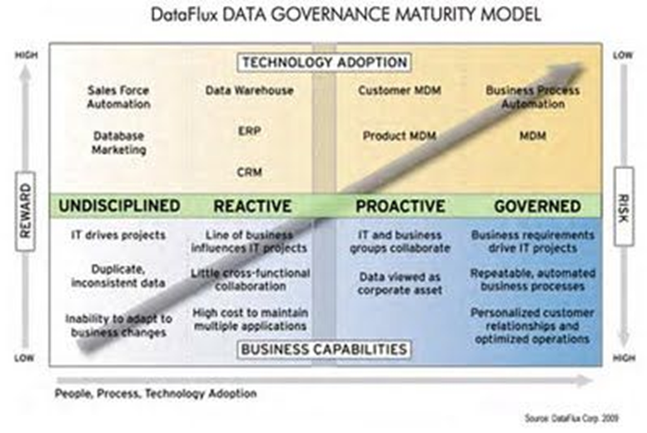

Above figure shows data DataFlux data governance maturity process framework. From the framework we can view that each maturity level relationship to business capabilities or behaviors and also adopted technologies examples. Rewards will be higher and risk will be lower at the higher level of data governance maturity.

# Data Governance Maturity Model: IBM Data Governance Council’s

IBM Data Governance Council’s Maturity models was created by IBM is based from Capability Maturity Model (CMM) which was introduced by Software Engineering Institute (SEI).This model characterizes set of domains that constitute data governance. The 11 domains are group into 4 groupings which are Outcomes, Enable, Core Disciplines and supporting Disciplines. The relationship between the domains and grouping is shown as below.

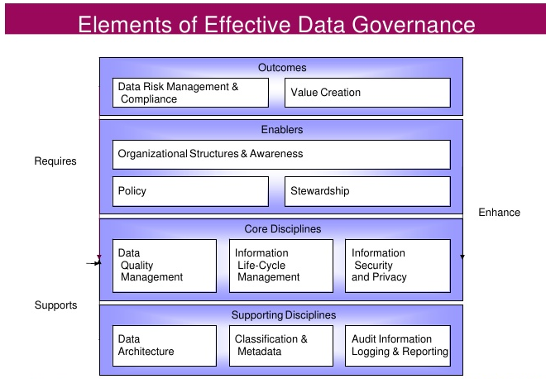

From the figure above, we can summarize that in order to achieve business Outcomes, Enablers group are required which this Enabler group are supported by Core Disciplines and Supporting Disciplines. For this model, maturity is assessed and evaluated individually by using scale from 1 to 5.

Phases or level for IBM Data governance Maturity Model is as below.

|  |  |  |
| --- | --- | --- |
|  | Level of Maturity | Characteristics |
| 1 | Initial | Process unpredictable, poorly controlled and REACTIVE |
| 2 | Managed | Process characterized for PROJECTS and is MANAGEABLE |
| 3 | Defined | Process characterized for the ORGANIZATION and is PROACTIVE |
| 4 | Quantitatively Managed | Process QUANTITATIVELY measured and controlled |
| 5 | Optimizing | Focus on CONTINUOUS process improvement |

Maturity level as in table will be used to assess each domain individually.

# Data Governance Maturity Models: MDM Institute

This maturity model was introduced by MDM (Master Data Management) Institute which is based in California, United States. This model can be a good stepping stone to initiate Data Governance maturity model. MDM Institute maturity model focus on moving from initial state which is Basic (reactive process, no control, application and project based) to more standardized and Distinctive state. This migration is done by leveraging service oriented architecture as the basis for the approach. The approach will comprise of planning, designing and implementing enterprise services, data services and information services. This model is adopting the concept of an evolving maturity but is phased with fewer steps. For this model, the higher levels of the organization business side will be playing an active role.

Phases or level for MDM Data governance is as below table.

|  |  |  |
| --- | --- | --- |
|  | Level of Maturity | Characteristics |
| 1 | Basic  (“anarchy”) | * Data governance for this level is only for application-centric or being applied for specific project basis |
| 2 | Foundational  (“IT monarchy”) | * Standardization policies is introduced for technology and methods whereby across projects, the usage of common tools and shared procedure are being applied |
| 3 | Advanced  (“business monarchy”) | * Data is rationalized in which data and metadata are being shared in production across data originator. |
| 4 | Distinctive  (“Federalist”) | * SOA are the based for the process. * Standard components are having incorporated view of conformity requirements. * Organization are formalized with definite roles and responsibilities. * The metric scope are defined * Iterative learning scope are defined |

# Data Governance Maturity Models: Oracle Corporation

This maturity model was introduced by Oracle Corporation which is reputable for its well design data architecture fundamental.

From their point of view, in order to have an effective data governance and converting data into strategic assets for the enterprise, all the dimension such as people, processes and technology need to be correctly align. The process of controlling and leveraging key data assets within any organization is an evolutionary process. This maturity model will be used to determine steps that are needed by enterprise to improve its capabilities in data governance. It can also assist in helping enterprise determining current level in their data governance discipline progress and help to identify short-term steps that is needed to elevate them to the next level. Each of the steps taken in this evolution will have measureable key performance indicator. This key performance indicator will reflect the real investment return which will justify the cost for the steps taken for improving data governance.

Phases or level for Oracle Corporation Data governance is as below.

|  |  |  |
| --- | --- | --- |
|  | Level of Maturity | Characteristics |
| 1 | Stage I : Marginal | * Organization is understanding the need for data governance. * Data quality initiative scope need to be expand. * Data stewardship capabilities need to be added |
| 2 | Stage II : Stable | * Data governance initiatives are being implemented by division wide with data governance teams established * To help drive demand for further progress, the successes achieved at this level are being promoted and socialize. * To resolve data ownership and access rights across the division, enterprise wide teams need to be created. * Deployment of Master Data management solutions are needed |
| 3 | Stage III : Best Practice | * Data Governance best practices are being implemented across the enterprise * Master Data Management execution engines are executing Data Governance policies automatically. * In order to get repot results directly to governance committees, feedback loop are established. |
| 4 | Stage IV : Transformational | * Proven quality data and business intelligent tools are integrated across all business processes to help organization achieving transformational status |

# Data Governance Maturity Models: Gartner’s EIM

Gartner’s enterprise information management (EIM) data maturity model was introduced in December 2008. Gartner believe that EIM should be handles as continuing and evolving program rather than defining it as a single project. This model suggest that information should be manage as an asset causing this idea to gain attention from top management. Gartner EIM data maturity model was developed as a steering tools to organizations that are committed on administrating information assets based on Gartner definition of EIM. Action item are provided for each level of this maturity model which concept is to integrate enterprise wide method in managing information assets. 5 major goals are set which comprise of an EIM discipline

Gartner EIM Goals

* + 1. Unified content
    2. Integrated Master Data domains
    3. Seamless Information flow
    4. Meta Data Management and Semantic Reconciliation
    5. Data Integration across the IT portfolio

Phases or level for Oracle Corporation Data governance is as below

|  |  |  |
| --- | --- | --- |
|  | Level of Maturity | Characteristics |
| 0 | Unaware | * Strategic and important decision are being made with not enough information. * Unclear structure of information architecture, fundamentals or sharing of information process * Unclear structure of information governance, security and accountability * Meta data definitions, common taxonomies terminology, data vocabularies and data models is not fully understand. |
| 1 | Aware | * Value of information is understood * Data ownership issues * General standards, methods and procedures needs are recognized * Risks related to not properly managing information start to be recognized |
| 2 | Reactive | * Value of information is being recognized by business unit * Information is being shared across cross-functional projects * Steps are taken to integrate data sharing between department * Information quality is reactively being address * Multiple point to point interfaces * Metrics that specify current governance state are starting to be collected |
| 3 | Proactive | * For improving performance, information is viewed as a necessity * To enable enterprise wide initiatives, information is viewed as a necessity * Guidance for EIM program is provided by enterprise information architecture. * Governance function and structure becomes formalized * Integration between data governance and system development approach |
| 4 | Managed | * Information criticality is understood across enterprise * To achieve consistency, policies and standards are developed and understood across the enterprise. * Issues related to cross-functional information management is resolve by established governance organization * Information assets gain and valuation developed * Productivity metrics are established |
| 5 | Managed | * Information gain ad also value is gathered throughout information supply chain * Establishment of Service level agreements * Proper exploit of information assets will result competitive advantage gain to be acknowledge by top management * EIM approaches involve risk management and also productivity targets * The organization structure of EIM is normalized by adopting project management steps approach. The EIM organization coordinates activities across the enterprise |

# Summary

Below table summarize the different between above mentioned 5 different Data Governance Maturity model.

|  |  |  |  |  |  |
| --- | --- | --- | --- | --- | --- |
| Maturity model name | DataFlux | IBM | MDM Institute | Oracle Corporation | Gartner EIM |
| Aim | This data maturity model is looking at business perspective and how to manage data as an enterprise asset. This can be achieved by employing means such as organization, process and technology to gain level of data quality. | To determine and manage progress through various maturity levels within the 11 IBM data governance domains | To move from initial state which is Basic (reactive process, no control, application and project based) to more standardized and Distinctive state | To determine steps that are needed by enterprise to improve its capabilities in data governance | As a steering tools to organizations that are committed on administrating information assets based on Gartner definition of EIM by approaching five major goals that comprise an EIM discipline |
| Scope | Business perspectives for managing data as Enterprise assets.  Service oriented architecture (SOA) | IBM Data  Governance Council domains | SOA  MDM | SOA,  BPM  Business intelligence systems | Enterprise information Management(EIM) |
| Attribute/  Domain/  Dimension/Goals | (Dimension)  People,  Policies,  Technology,  Risk | (Domains)  Data Risk ,  Management & Compliance,  Value Creation  Organizational  Structures & Awareness, Policy,  Stewardship,  Data Quality  Management,  Information Lifecycle Management,  Information Security & Privacy,  Data Architecture  Classification ,& Metadata  Audit ,  Information, Logging & Reporting |  |  | (EIM Goals)  Unified content,  Integrated Master Data domains,  Seamless Information flow,  Meta Data Management and Semantic Reconciliation,  Data Integration across the IT portfolio. |
| Level Name | Level 1: Undisciplined  Level 2: Reactive  Level 3: Proactive  Level 4: Governed | Level 1: Initial  Level 2: Managed  Level 3: Defined  Level 4: Quantitatively Managed  Level 5: Optimizing | Level 1: Basic  Level 2: Foundational  Level 3: Advanced  Level 4: Distinctive | Stage I: Marginal  Stage II: Stable  Stage III: Best Practice  Stage IV: Transformational | Level 0: Unaware  Level 1: Aware  Level 2: Reactive  Level 3: Proactive  Level 4: Managed  Level 5: Effective |